Examination of the skin
The major functions of the skin are:
- To maintain a normal body temperature(thermo regulatory).
- To maintain a normal fluid and electrolyte balance within the animal
- To act as a sensory organ perceiving those features of the environment which are important to the subject's survival.
- Convert cholesterol to vit. D
- Protect the body from external effect.
Diseases of the skin :- Diseases of the skin may be:-
- Primary or( direct ).
2- Secondary in origin.(in direct )
Primary skin disease the lesions are restricted initially to the skin although they may subsequently spread from the skin to involve other organs.
Secondary :- Cutaneous lesions may be secondary to disease originating in other organs.
Coat of animal
Erection of hair due to secretion of adrenalin hormone in case of fear,cold and excitation.
Alopecia
Etiology
Alopecia is in complet or complete absence of the hair or wool coat
Or infectious & non infectious Failure of the follicle to produce a fiber
- Nutritional causes(Zn,I,Co.Cupper,vit.A.Protein deficiency)
- Congenital
- Poisoning (Thalium ,Selenium,mercury).
- Inherited In baldy calves and adenohypophyseal hypoplasia

- Congenital hypothyroidism (goiter) due to iodine deficiency (hypothyroidism)
- After viral infection of the dam, alopecia congenitally in the newborn, e.g. after bovine virus diarrhea in cattle and infection by a similar virus in sheep (Border disease).
- Neurogenic alopecia due to peripheral nerve damage
- Infection in the follicle ring worm (microsporum,trichophyton) and mange(sarcoptic &psoroptic).
Color of hair and coat:
Change of skin and hair color due to Cupper deficiency.
Tissue and organ test :
Horn ,dewclaw,(color,size,shape)and shine>>>
FMD………effect of coronary band -----red color
Rings in horn ----------- bad feeding and evaluate the animal age .
Elasticity test :
by pool of fold in neckback ribs and lets the skin to return normaly.
But loss of skin elasticity in case of Eczyma and mange and emaciasion in nutritional deficiency ,Tb,leptospirosis
and loss of elasticity ---------dehydration(diarrhea and vomiting).
Elasticity test
0-2 second normal
2-4 s. mild
4-6 s moderate
6- above severe
Hair attachment test
Easy detachment of hair and wool mean emaciated of animal , bad nutrition or liver fluck(liver parasite),skin lesion. But normaly alittle hair or wool detachment by used two finger in this test.
Clinical signs and special examination
- A general clinical examination is followed by
- a special examination of the skin and must include inspection and, in most cases, palpation.
- Additional information can be obtained by
1-taking swabs for bacteriological examinations,
2-scrapings for examination for dermatophytes and metazoan parasites,
3 biopsy for histopathological examination. specimens, including non representative sampling, crushing the specimen by forceps or hemostat, and inadequate fixation.

External parasite :
Fly ,lice,mite ,tick
1.Hypoderma linatum
.H. bovis
2 screw worm
Worm of skin: stephanophilaria and paraphilaria multipapilosa (horse)
secondary lesion  Scales  crust  ulcer ( involve dermis)  Fissures  scar  erosion (on surface) | primary lesions  Vesicle,  buIla, blister  Pustule  Wheal  Papules (pimples)  Nodules, nodes  Plaque  Macule (patch)

Abnormal coloration of skin

This parameter includes
jaundice, pallor and erythema, and these are best seen in the oral or vaginal mucosa or in the conjunctiva. In animals they are rarely visible in light-colored skins.
*Red-purple discoloration of the skin of septicemic,
*Early erythema is a common finding where more definite skin lesions
are to develop, as in early photosensitization.
*The blue coloration of early gangrene (e.g. of the udder and teat skin
in the early stages of peracute bovine mastitis associated with Staphylococcus aureus) is characterized by coldness and loss of elasticity.
- Hypopigmentation of the skin:- may be general. As
- in albino, pseudoalbino and lethal white animals.
- Local patches of hypopigmentation are characteristic of vitiligo
and leukoderma.
-----------------------------------------------------------------------
Pruritus
Pruritus or itching is the sensation that gives rise to scratching .
Pruritus can arise:-
from *Peripheral or *Central stimulation.

***********************************
Secretion abnormalities of skin glands
The activity of the sweat glands is controlled by the sympathetic nervous system and is for the most part a reflection of body temperature. Excitement and pain may cause sweating due to cerebral cortical activity
Abnormalities of wool and hair fibers
alopecia or hypotrichosis :-Deficiency of hair or wool in comparison to the normal pilosity of the skin area .
and the wool becomes straight and 'steely'. Alternation in coat color, achromotrichia, may be generalized or segmental along the fiber.

HYPERKERATOSIS
Epithelial cells accumulate on the skin as a result of excessive keratinization of epithelial cells and intercellular bridges, interference with normal cell division in the granular layer of the epidermis and hypertrophy of the stratum corneum.
Lesions may be:-
Parakeratosis
Parakeratosis, a skin condition characterized by incomplete keratinization of epithelial cells, can be: Caused by
- nonspecific chronic inflammation of cellular epidermis
- Associated with dietary deficiency of zinc
- Part of an inherited disease

Impetigo
A superficial eruption of thin -walled, small vesicles, surrounded by a zone of erythema, that develop into pustules, then rupture to form scabs.
but some persist as yellow scabs.

URTICARIA
An allergic condition characterized by cutaneous wheals. It is most common in horses
Photosensitization
1. photodynamic agents
2. Hepatogenous photosensitization
Skin scraping

Skin scping was carried out (after applying vaseline ointment on the affected area to prevent spreading of hair) by using a blunt scalpel, hairs collected particularly from the peripheral lesions in Petri dishes .add 10% KOH or 10% NaOH. To solved the keratin > this test used to difrentiate between ring worm ( Hyphae) and mange (mites) microscopicaly.

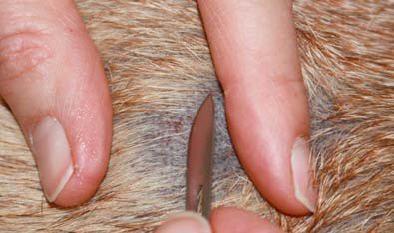

Skin culture

Bacterial Cultures:
Intact pustules can be cultured by rupturing the pustule with a sterile needle and swabbing the lesion with a sterile culture swab. .
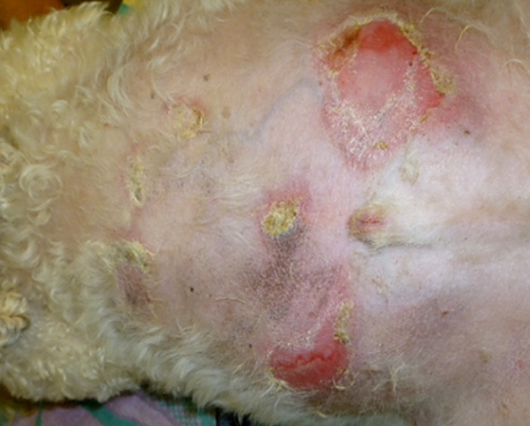
The lesion for bacterial culture

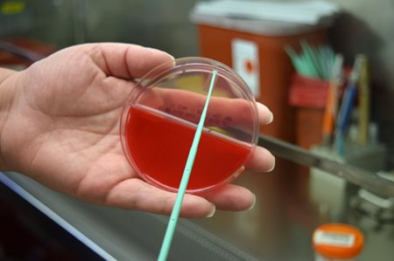
Swab Culture in media

Biopsy:

1. Tthe specimen should be placed in a 10% buffered formalin solution provided by pathology.

2. each specimen should be placed into a separate bottle and identified.

3. Specimens less than 1 cm in greatest dimension can be adequately fixed in 30 mL of formalin, but larger specimens will require more formalin and Biopsy specimens require examination by a pathologist
.
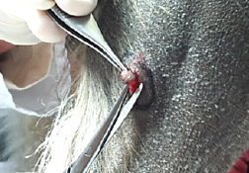
Skin Biopsy Technique for histopath test

